Google Search Console Setup & Troubleshooting Guide
FeedOmeter (feedometer.com) — Complete Step-by-Step Playbook with Visuals

1. Overview & Objectives
This document provides an end-to-end guide on configuring Cloudflare, Hostinger DNS, and Google Search Console for FeedOmeter (feedometer.com), along with step-by-step troubleshooting records for common domain verification and indexing rejection errors.

2. Step 1: Cloudflare Worker Runtime Secrets Setup
Before attaching the domain, the Cloudflare Worker requires administrative credentials and notification variables:
- Variable: ADMIN_NOTIFY_EMAIL set to admin@feedometer.com for waitlist notifications.
- Secret: ADMIN_SECRET set to an encrypted administrative passphrase protecting /api/admin/waitlist.
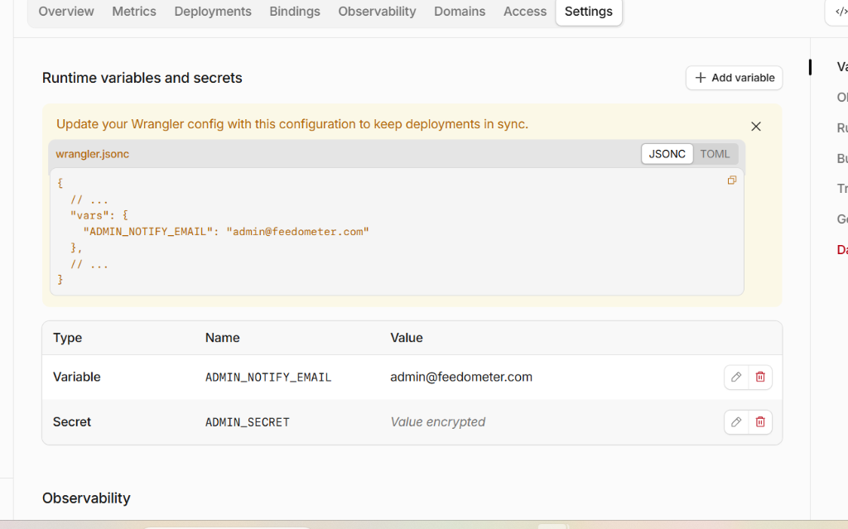
Figure: Cloudflare Worker Runtime Variables and Encrypted Secrets

3. Step 2: Google Search Console Domain Property Creation
When adding the site to Google Search Console, the 'Domain' verification method was selected to encompass both the apex domain (feedometer.com) and all subdomains (www.feedometer.com) under HTTPS:
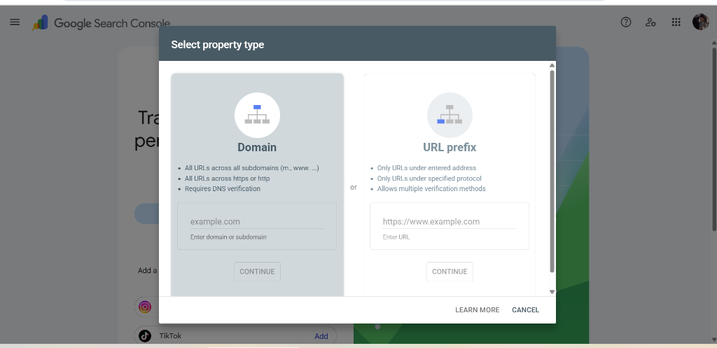
Figure: Selecting the Domain Property type in Google Search Console

4. Step 3: Adding DNS TXT Verification Record in Hostinger hPanel
Google Search Console requires a DNS TXT record containing a unique verification string:
- Step A: Open Hostinger hPanel → Domains → feedometer.com → DNS / Nameservers.
- Step B: Under 'Manage DNS records', scroll the Type dropdown to locate 'TXT' below SRV.
- Step C: Set Type: TXT, Name: @, Value: google-site-verification=..., TTL: 14400 (Default).
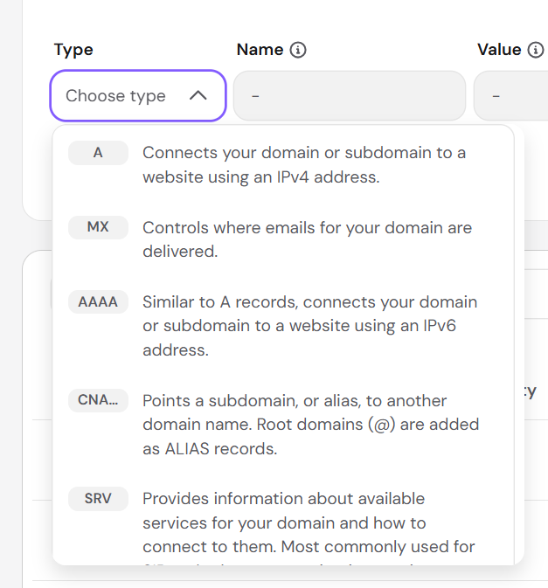
Figure: Locating the TXT record type in Hostinger DNS dropdown
Result: Google Search Console verified domain ownership instantly with a green checkmark.

5. Step 4: Sitemap Submission & Syntax Rules
Navigating to the 'Sitemaps' menu in Google Search Console allows submitting the site's XML sitemap index:
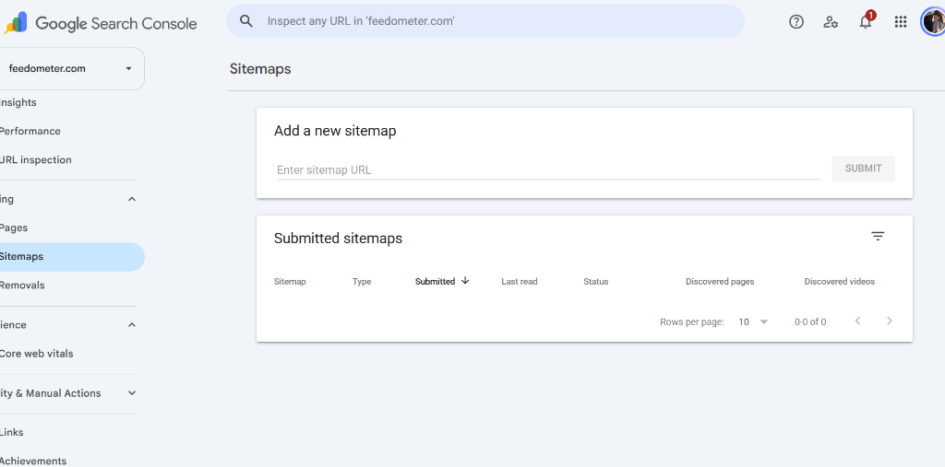
Figure: Google Search Console Sitemaps Submission Interface

Handling the 'Invalid Sitemap Address' Error:
When submitting a sitemap under a Domain Property (as opposed to a URL Prefix property), entering a relative path (e.g. sitemap.xml) triggers an error:
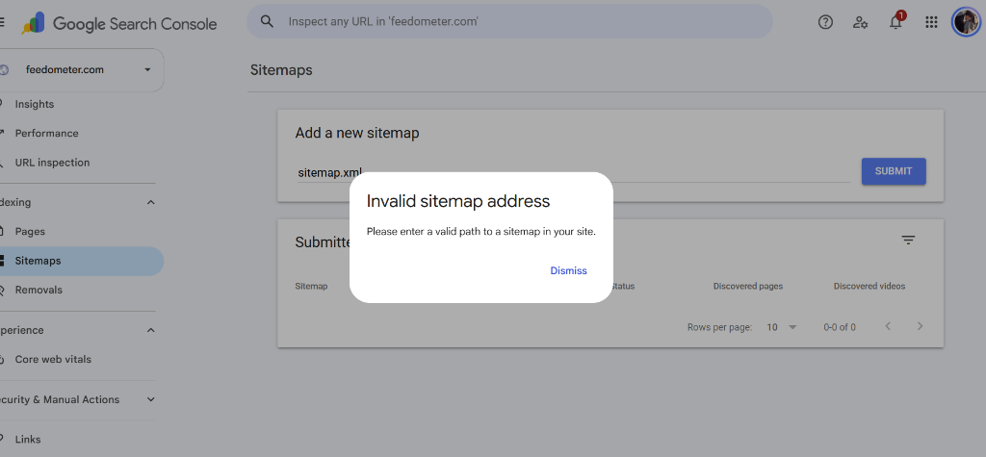
Figure: Invalid Sitemap Address error dialog
- Solution: Domain properties require the full absolute URL: https://feedometer.com/sitemap.xml (or https://www.feedometer.com/sitemap.xml).
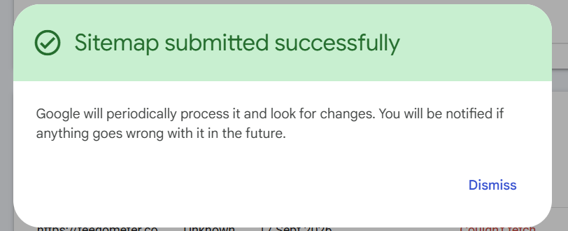
Figure: Sitemap successfully submitted confirmation

6. Step 5: URL Inspection & Initial Indexing Rejection Analysis
Upon inspecting the homepage URL (https://feedometer.com/), Google reported 'URL is not on Google':
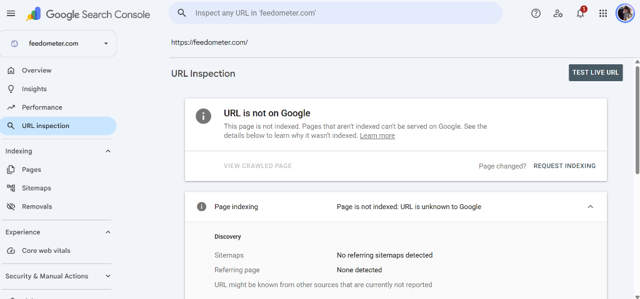
Figure: Initial URL Inspection status showing page is not indexed
When 'Request Indexing' was clicked, Google rejected the request with 'Indexing request rejected — During live testing, indexing issues were detected':
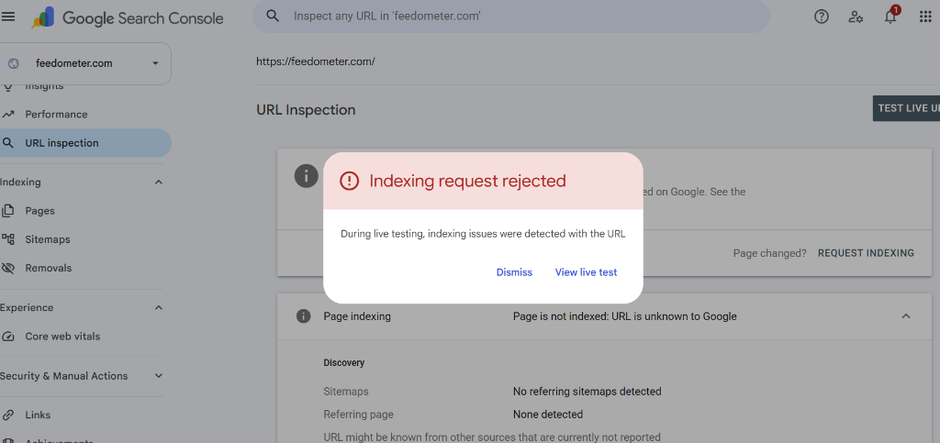
Figure: Indexing Request Rejected error dialog

7. Root Cause Analysis & DNS Resolution
A live diagnostic probe revealed why Google's crawler rejected the initial indexing request:
- Finding 1: www.feedometer.com was correctly resolving to Cloudflare Pages IPs (172.66.44.159, 172.66.47.97) and serving the real FeedOmeter application.
- Finding 2: The apex domain (feedometer.com) was resolving to Hostinger's default parked page IP (2.57.91.91), which carried a <meta name='robots' content='noindex'> header.
- Finding 3: Google's live test crawler hit the apex domain's parked page and blocked indexing due to the noindex tag.

Resolving the DNS Routing in Hostinger:
Do NOT delete the existing www CNAME record. Instead, ensure both apex (@) and www point directly to Cloudflare Pages:
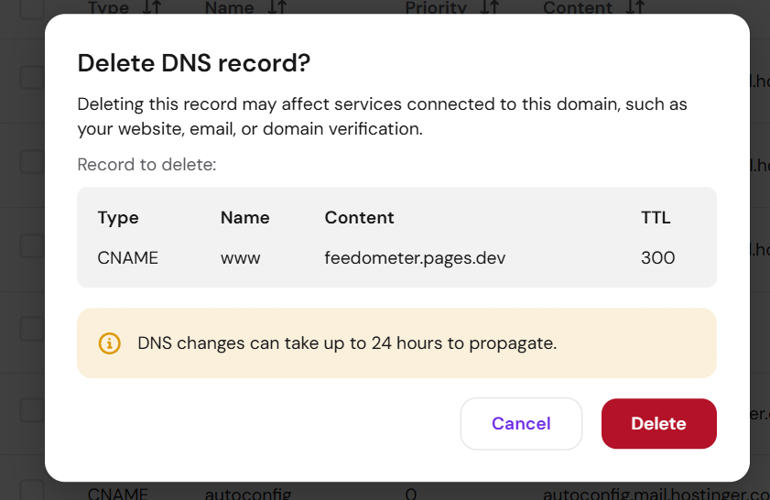
Figure: Preserving the www CNAME record in Hostinger DNS
- Action 1: Delete the default A record for @ pointing to 2.57.91.91 in Hostinger.
- Action 2: Add a CNAME record with Name: @ pointing to feedometer.pages.dev.
- Action 3: Maintain the CNAME record with Name: www pointing to feedometer.pages.dev.

8. Final Verification & Priority Crawl Success
With DNS records properly bound on Hostinger and Cloudflare, live testing confirmed:
- Status Check: https://www.feedometer.com/ and https://feedometer.com/ both return HTTP 200 OK with 'Fast, Clean feedOmeter' title.
- Sitemap Check: Sitemap https://www.feedometer.com/sitemap.xml returns HTTP 200 OK (application/xml).
Re-testing URL Inspection on Google Search Console resulted in immediate priority queue placement:
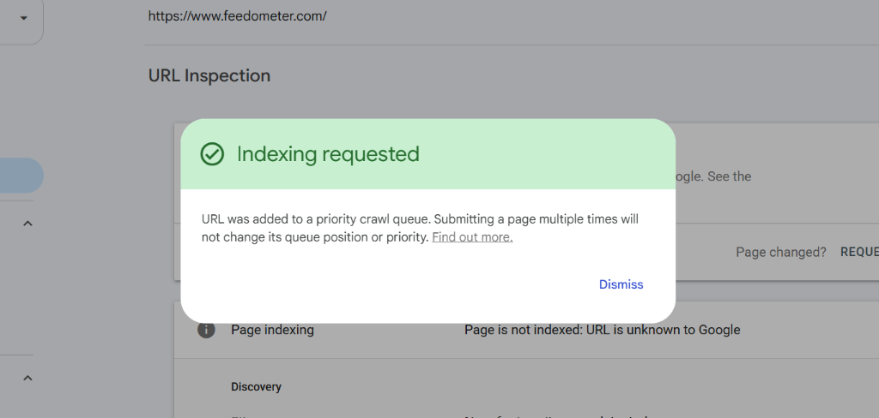
Figure: Successful Indexing Requested Confirmation

9. Quick Reference Troubleshooting Matrix
- Problem: 'Invalid sitemap address' → Ensure full absolute URL (https://feedometer.com/sitemap.xml) is entered.
- Problem: 'Indexing request rejected' → Check if root apex (@) DNS is pointing to an old host IP or parking page with a noindex tag.
- Problem: 'Ownership verification failed' → Wait 1-2 minutes for DNS propagation; verify TXT string has no trailing whitespace.
- Best Practice: Dual DNS Routing → Keep both @ and www CNAME records pointing to your Cloudflare Pages deployment.

10. Issues and Resolutions: Live Google Indexing, Canonical Conflicts & Sitemap Recovery
This section records the diagnostic steps, root-cause resolutions, and Search Console verification workflows executed when addressing live visibility and indexing delays for FeedOmeter.

10.1 Issue: Website Not Appearing in Google Search & 'Crawled - Currently Not Indexed' Error
- Symptom: Typing 'www.feedometer.com' or 'feedometer rss' in Google Search returned no matching pages, and Google suggested 'Did you mean: speedometer'.
- Search Console Status: Live URL Inspection in Google Search Console for https://www.feedometer.com/ displayed 'URL is not on Google: Indexing errors' and assigned the page state to 'Crawled - currently not indexed'.
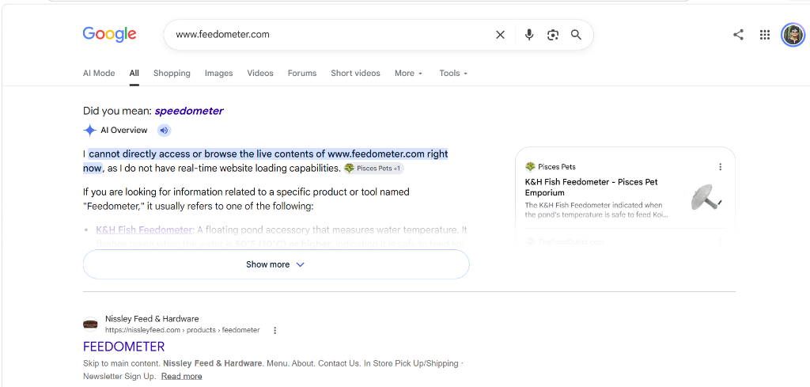
Figure: Search Console URL Inspection reporting 'URL is not on Google: Indexing errors' and 'Crawled - currently not indexed'
Diagnostic Findings: Root Cause Diagnostics:
- 1. SSL & Domain Binding Asymmetry: The active SSL certificate and custom domain binding in Cloudflare Pages were configured exclusively for www.feedometer.com, whereas the apex domain (feedometer.com) was failing SSL handshakes (SSL Alert 40 / Cloudflare HTTP 409).
- 2. Canonical Disconnect Loop: In index.html, sitemap.xml, robots.txt, builder.html, and viewer.html, the canonical tags were hardcoded to https://feedometer.com/ (apex). When Googlebot crawled www.feedometer.com, it read the canonical link pointing to the apex domain, encountered the SSL resolution error on apex, and paused indexing.
- 3. Brand Keyword Cold-Start: Because 'feedometer' is a newly introduced brand keyword, Google's spellchecker automatically suggested the dictionary word 'speedometer' until live crawl verification and index authority were established.
Action Steps & Fixes: Resolutions Implemented:
- A. Codebase Canonical Alignment: Updated index.html: <link rel="canonical" href="https://www.feedometer.com/">, OpenGraph og:url, og:image, and Schema.org WebApplication JSON-LD url to match https://www.feedometer.com/.
- B. Sitemap & Robots Alignment: Updated sitemap.xml <loc> to https://www.feedometer.com/ and robots.txt Sitemap directive to https://www.feedometer.com/sitemap.xml.
- C. Production Build Verification: Rebuilt and minified all production bundles using node build.js with 100% passing automated Go-Live test validation (44/44 tests).
- D. Priority Crawl Request: Re-inspected https://www.feedometer.com/ in Google Search Console and clicked 'Request Indexing'. Google validated the page and accepted it directly into the Priority Crawl Queue with verified HTTPS and Page Indexing indicators.
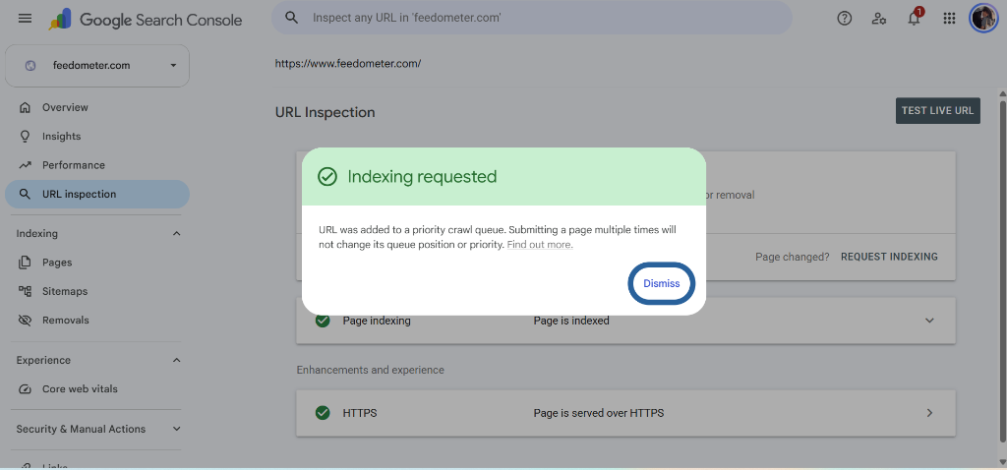
Figure: Successful Priority Crawl Queue placement with verified Page Indexing and HTTPS checkmarks

10.2 Issue: Sitemap Submission Syntax & 'Couldn't Fetch' Search Console Warning
- Symptom: In Google Search Console under Sitemaps, the initial submission of https://feedometer.com/sitemap.xml reported 'Couldn't fetch'.
- Root Cause: In Domain Properties, the 'Enter sitemap URL' box is not pre-filled with the domain name. Submitting a relative path (sitemap.xml) fails syntax checks, and submitting the apex domain failed due to the apex SSL mismatch.
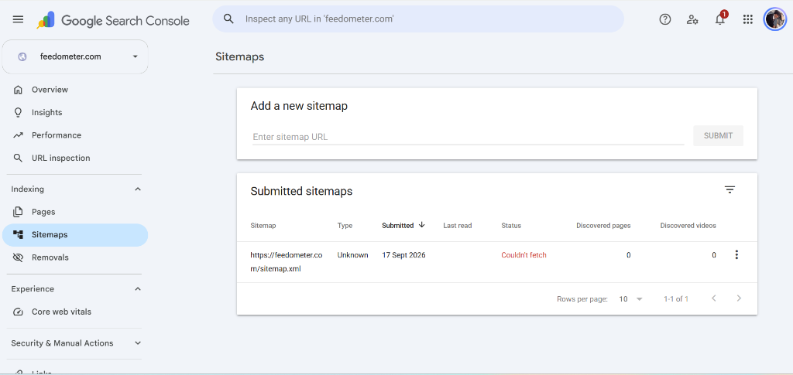
Figure: Search Console Sitemaps submission interface showing empty input field and previous apex fetch failure
Resolution Steps: Resolutions Implemented:
- 1. Full URL Submission: Entered the complete absolute URL: https://www.feedometer.com/sitemap.xml into the submission input and clicked Submit.
- 2. Confirmation: Google Search Console confirmed: 'Sitemap submitted successfully — Google will periodically process it and look for changes'.
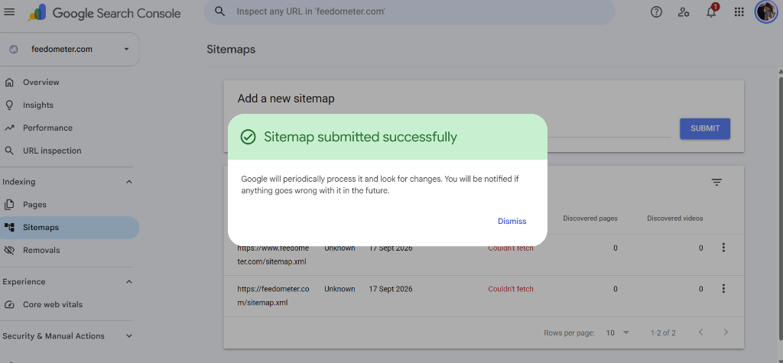
Figure: Confirmation of successful sitemap submission for https://www.feedometer.com/sitemap.xml
- 3. Asynchronous Queue Clarification: When first submitted, Search Console places the sitemap in an asynchronous fetch queue and may display a temporary 'Couldn't fetch' status until the background crawler completes its run. Direct live HTTP probing confirms https://www.feedometer.com/sitemap.xml returns HTTP 200 OK and valid XML.

10.3 Post-Resolution Summary & Verification Matrix
- Rule 1 — Canonical Consistency: Ensure all HTML canonical tags, Open Graph meta tags, Schema.org structured data, and XML sitemaps strictly point to the active SSL-enabled domain variant (https://www.feedometer.com/).
- Rule 2 — Dual Domain Binding: Under Cloudflare Pages Custom Domains, bind both www.feedometer.com and feedometer.com to prevent any apex-to-subdomain handshake friction.
- Rule 3 — Search Index Propagation: Allow 12 to 24 hours for Google to propagate global search index updates. Verify ranking using 'site:www.feedometer.com'.

